**Service Status Change**

Sample Ticket : - 270671940

1. The ticket should be validated to verify that the issue is relevant to BBW.

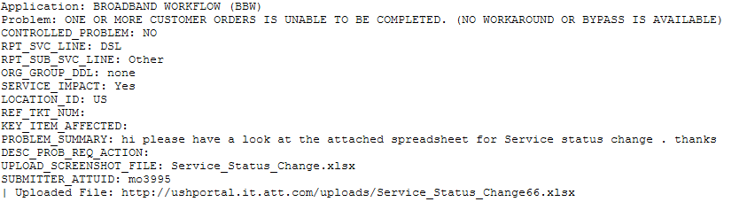

Here, Application, RPT_SVC_LINE and PROBLEM_SUMMARY fields help in determining the nature of ticket. In BBW all the relevant tickets will have their RPT_SVC_LINE as DSL. If you receive it as something else then either it is a user’s mistake or the ticket probably does not correspond to BBW, although checking once with user is advised before closing ticket just based on these factors.

Opening the attached spreadsheet you will find further details where updates are needed to be performed.



Here the mentioned BBW case 6561914 is in “Provisioning Pending” state which is causing impediment in the processing of order to billing. The order state should have been automatically changed to “In-Service” , however in some cases this does not happen.

Such as scenario is reported by the user and needs DB updates to be made manually.

1. Since SIID and Order number both are provided by the user, either can be used to check and update the requested fields.
2. Lets proceed with the first method:- **SIID**

SIID provided by the user here comprises of the **site ID** and the **access sequence**, in the above case the site id is 1443568 and the access sequence is 1.

To check the DB based on the user provided SIID, we need to fetch data based on the site id.

select site_id, access_point_status, order_number from table_service_point where site_id = '1443568' AND access_seq = '1'**;**



Once the **access_point_status** field is identified, to update the field following query can be used.

update table_service_point set access_point_status = 'In-Service' where site_id = '1443568' AND access_seq = '1'

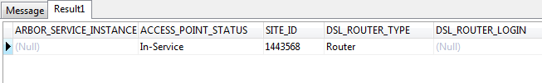

1. The second method of executing the update is based off of the **Order Number** provided by the user.

select site_id, access_point_status, order_number from table_service_point where order_number = 'FMOB1153144';

and once the field to be updated is identified, execute the following query.

update table_service_point set access_point_status = 'In-Service' where order_number = 'FMOB1153144';

1. Once the necessary updates have been completed, update the USH with appropriate details.
2. Intimate the user for validation
3. After validation has been completed, proceed to set the ticket to RTC.